# Week 01 Solutions

1. 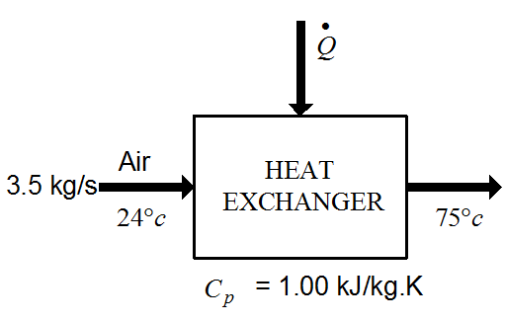



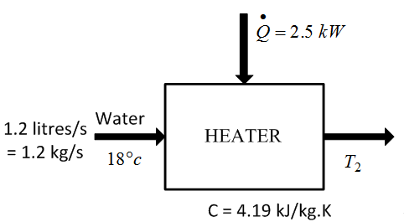







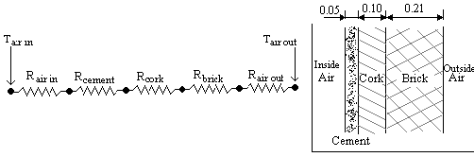





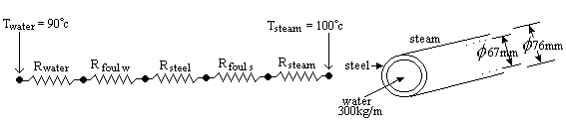















1. When the cold temperature is reduced this function reduces, basically because the effort needed to move heat from a low to a high temperature reservoir gets larger as the temperature difference gets larger.
2. For very similar reasons, when the high temperature gets higher, the effort required to move heat from the low to the higher temperature gets greater.
3. The vapour compression cycle responds to temperature changes in a very similar way to the Carnot cycle. If you plot a cycle and then another with a lower evaporating temperature you will see that the enthalpy change across the evaporator reduces and the compressor enthalpy rise increases. Both leading to a lower COP.
4. When the condensing temperature rises, the compressor enthalpy rise increases and the evaporator enthalpy rise reduces, both leading to lower COP.
5. The vapour compression cycle has intrinsic irreversibility in the expansion valve and in de-superheating in the condenser (to illustrate this, try and imagine how both processes could be reversed without supplying additional external work or heat). The Carnot cycle is by definition fully reversible and therefore, according to the 2nd Law of Thermodynamics, must be more efficient than any other cycle working between the same temperatures.
6. A refrigerator operates on an ideal vapor-compression refrigeration cycle between two specified pressure limits. The rate of refrigeration, the power input, the rate of heat rejection, and the COP are to be determined. Assumptions: Steady operating conditions exist. Kinetic and potential

energy changes are negligible. We note that this is an ideal vapor-compression refrigeration cycle, and thus the compressor is isentropic and the refrigerant leaves the condenser as a saturated liquid and enters the compressor as saturated vapor. From the refrigerant-134a tables, the enthalpies of the refrigerant at all four states are determined as follows:

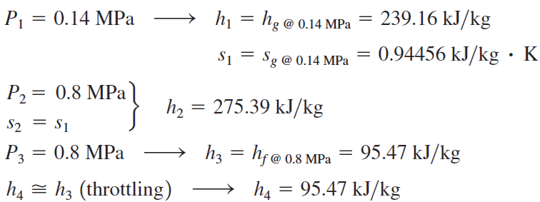

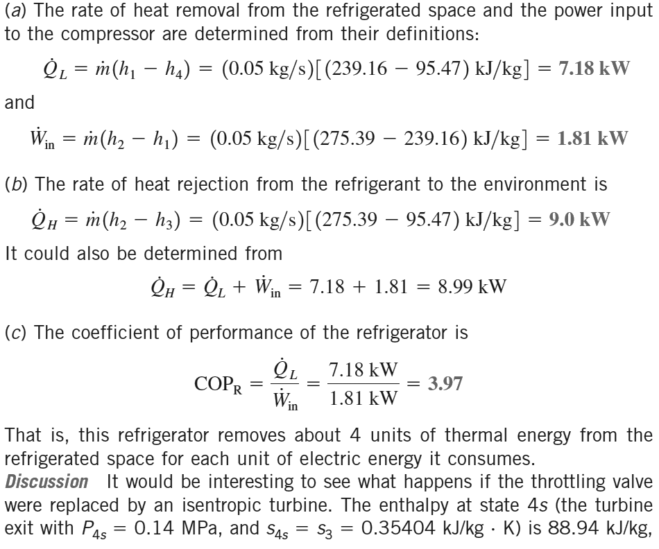

1. A commercial refrigerator with refrigerant-134a as the working fluid is considered. 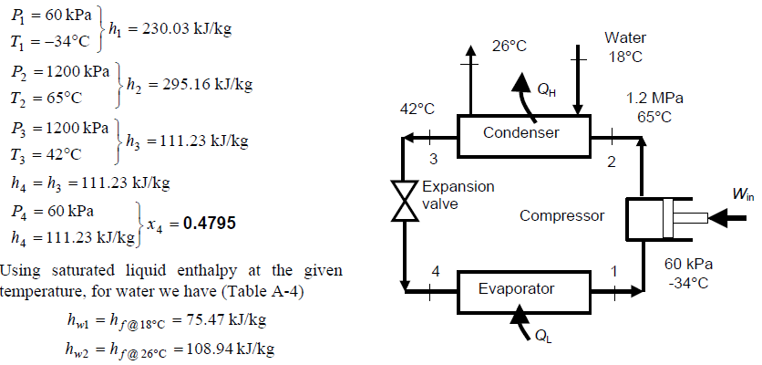

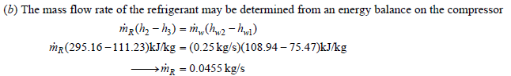

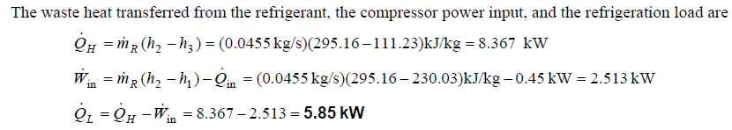

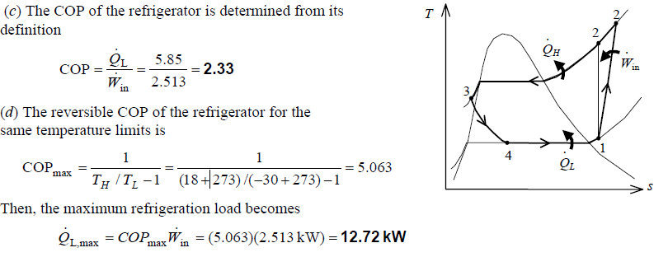

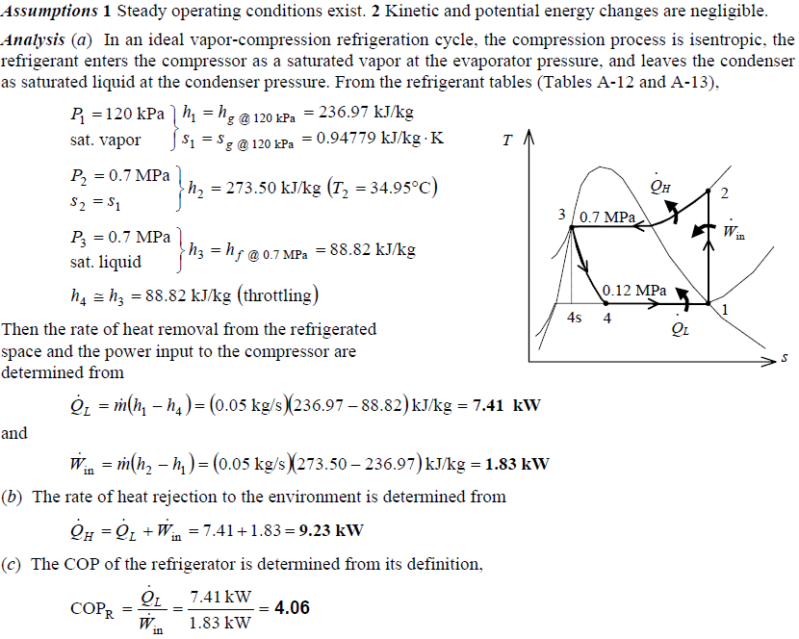

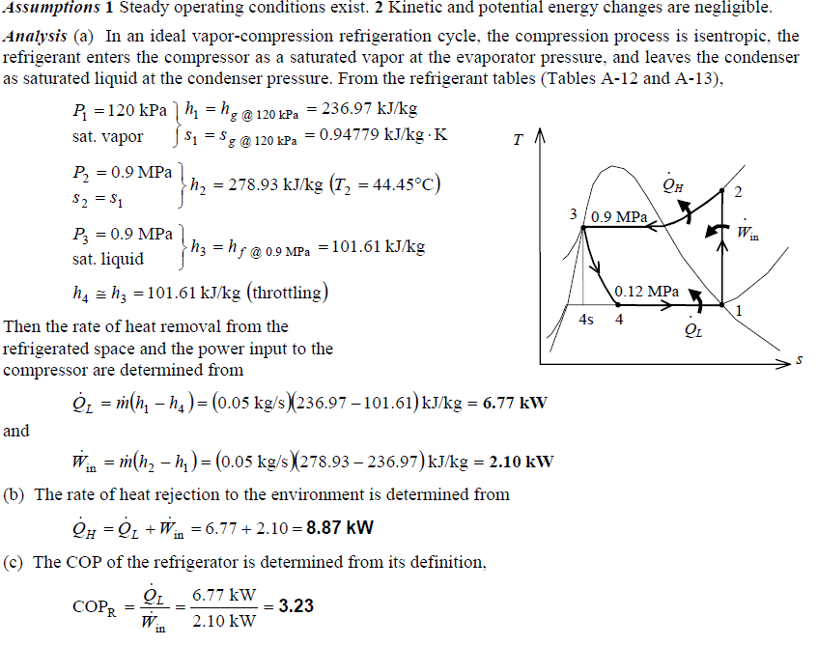

a)

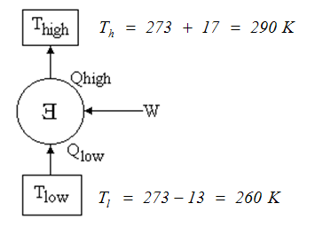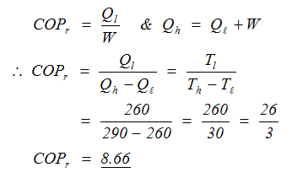

b)

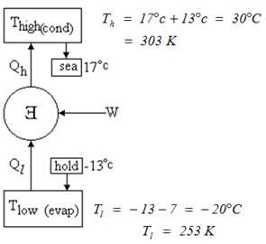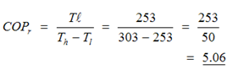

c) 





The COP is poor chiefly because a throttle was used to expand the fluid rather than an engine. This represents lost work potential so the W required to drive cycle is greater since there is no help from the expander. Furthermore, the mixture coming out of the throttle has the same enthalpy as it had when entering, whereas the fluid coming out of an expander engine would have less enthalpy and hence be able to absorb more heat in the evaporator. Thus the throttle system has less cooling capability than a system that uses an engine expander. The increased W and reduced Qcool that exist in a throttled system both make the system have a lower COP than a system that has an engine instead of a throttle.

The other difference with the Carnot cycle is that the vapour is being compressed in the superheat region and has to be raised to a higher temperature than it would if compression in the wet region occurred (as it does in the Carnot cycle). This dry compression involves more work per unit mass than wet compression.



d)

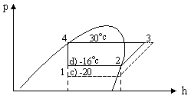



e)

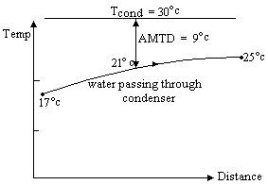





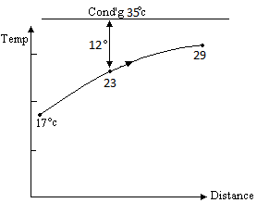

[D] 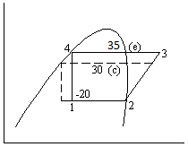





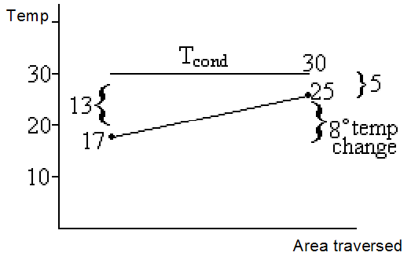



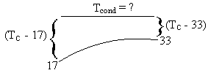

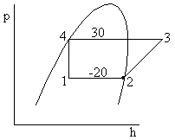









C&G 5th Edn Answers

3-64

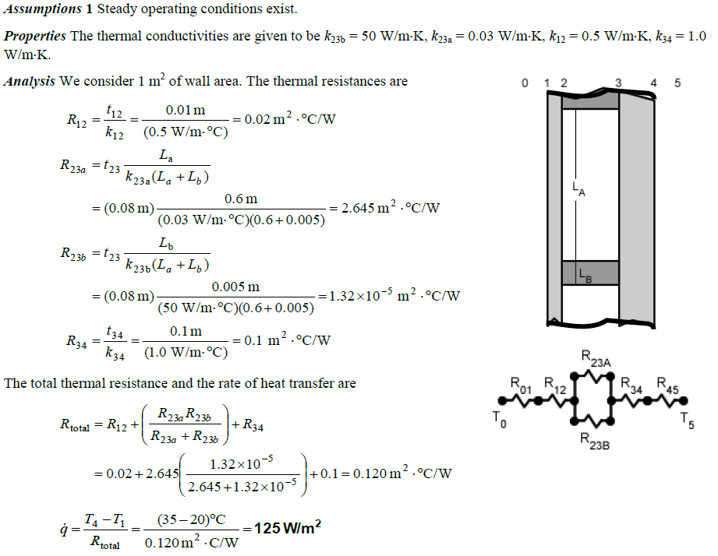

3-76

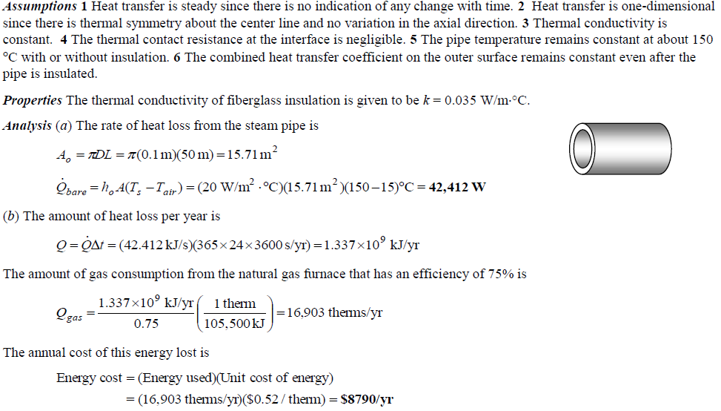

3-76 - continued

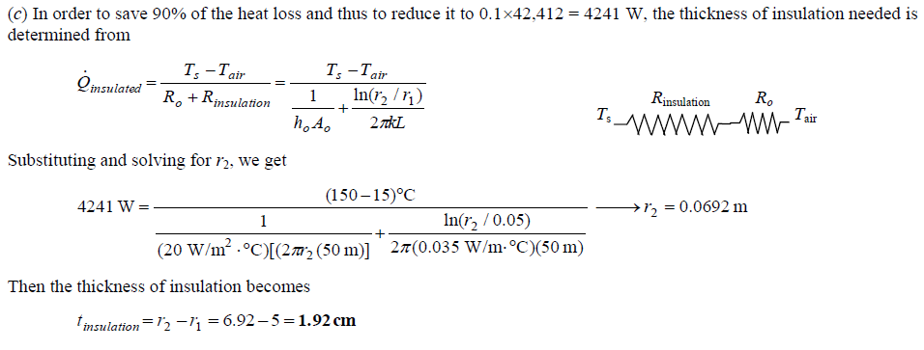

3-77

